**BRAC UNIVERSITY**

**B**

**Department of Computer Science and Engineering**

**CSE420: Compiler Design**

**Quiz 02, Spring 2016**

**Duration: 1.00 hours, Total Marks: 30**

|  |
| --- |
| Student Name:  Student ID:  Section: |

**1.** What is S-attributed definition? “Every L-attributed definition is not S-attributed” – Justify your answer. **[1+1]**

*The answer will be just the opposite of set A*

**3.** A syntax directed definition for declaring identifiers is:

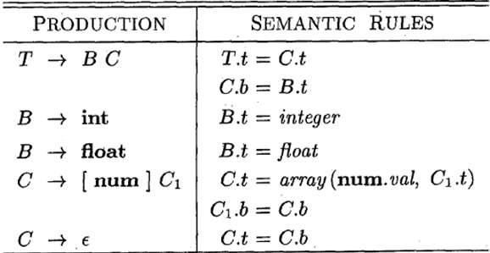

i) Draw an annotated parse tree for the sentence: *a[5][2]*

ii) Draw the dependency graph for the parse tree of (i). **[4 + 2]**

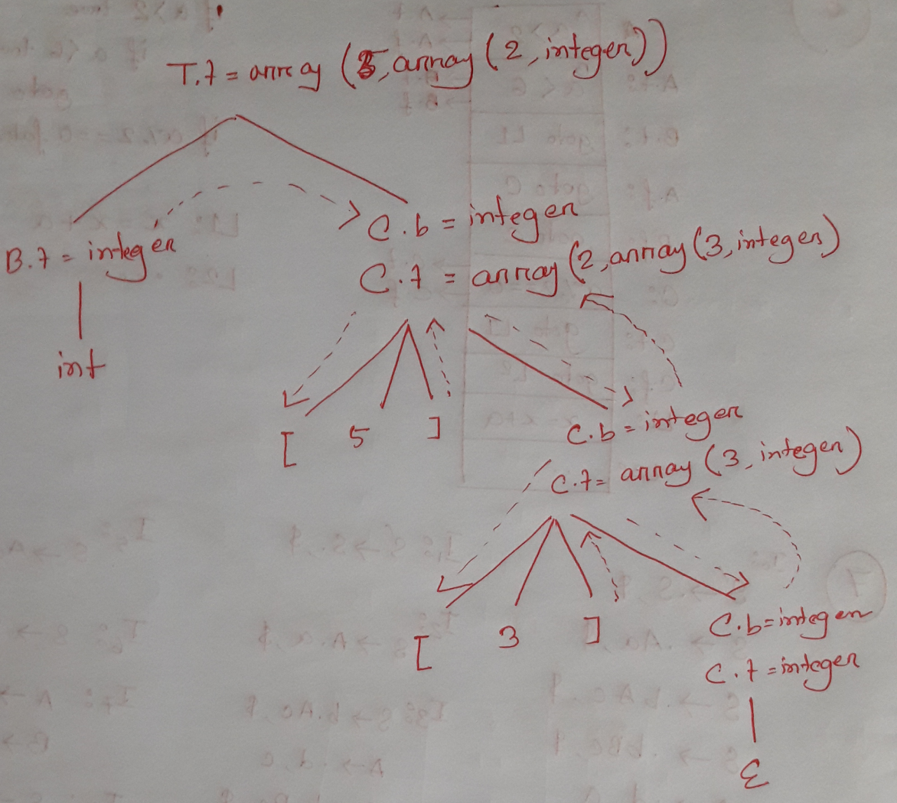

**4.** Translate the expression *x=a[i][j]* into: **[3+2]**

i) Quadruples,

ii) Triples,

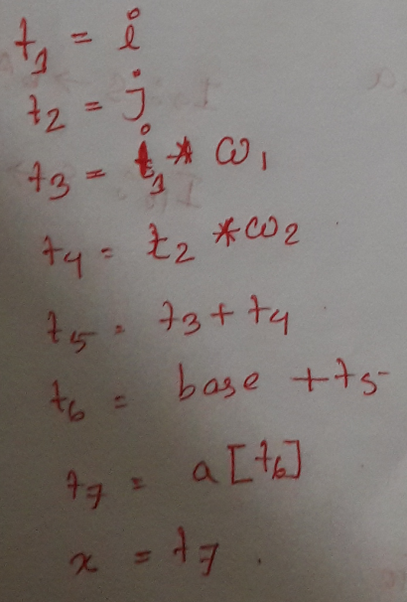

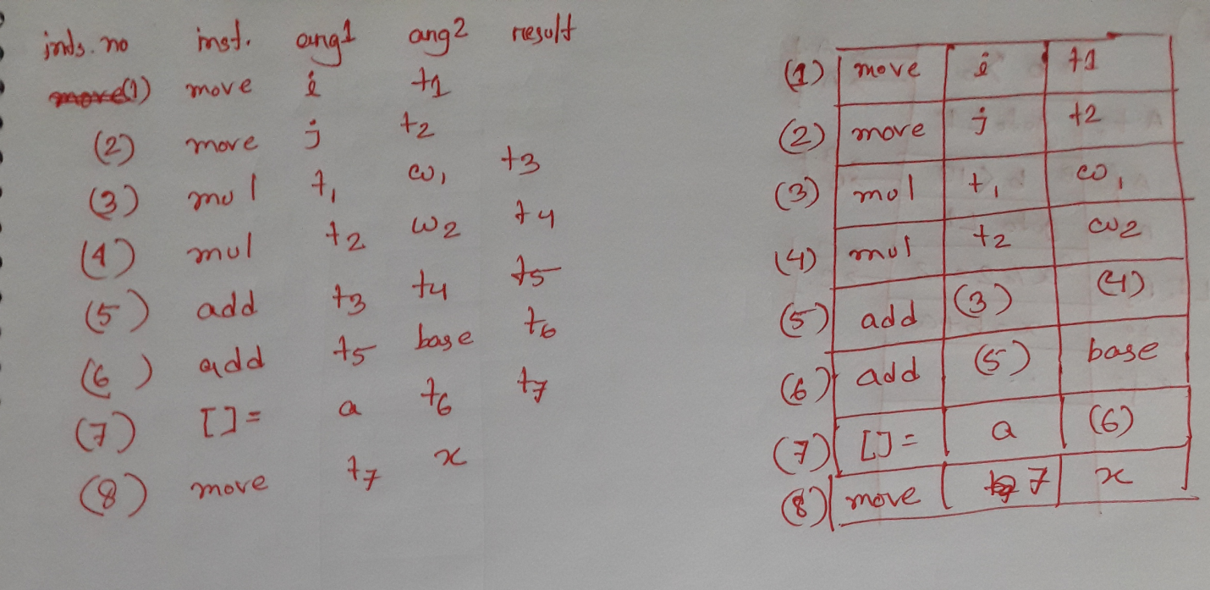

**5.** Determine the target statements of following code segment using the techniques of back-patching: **[6]**

|  |
| --- |
| while (m>2 || m==1) {  m=m+1;  x=m*2;  }  System.out.println(m+” ”+x); |

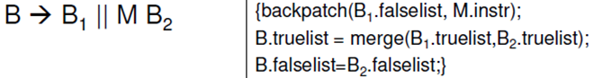

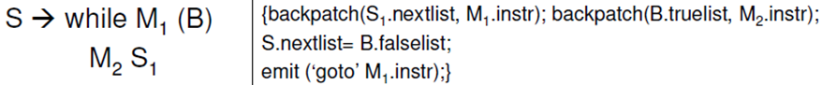

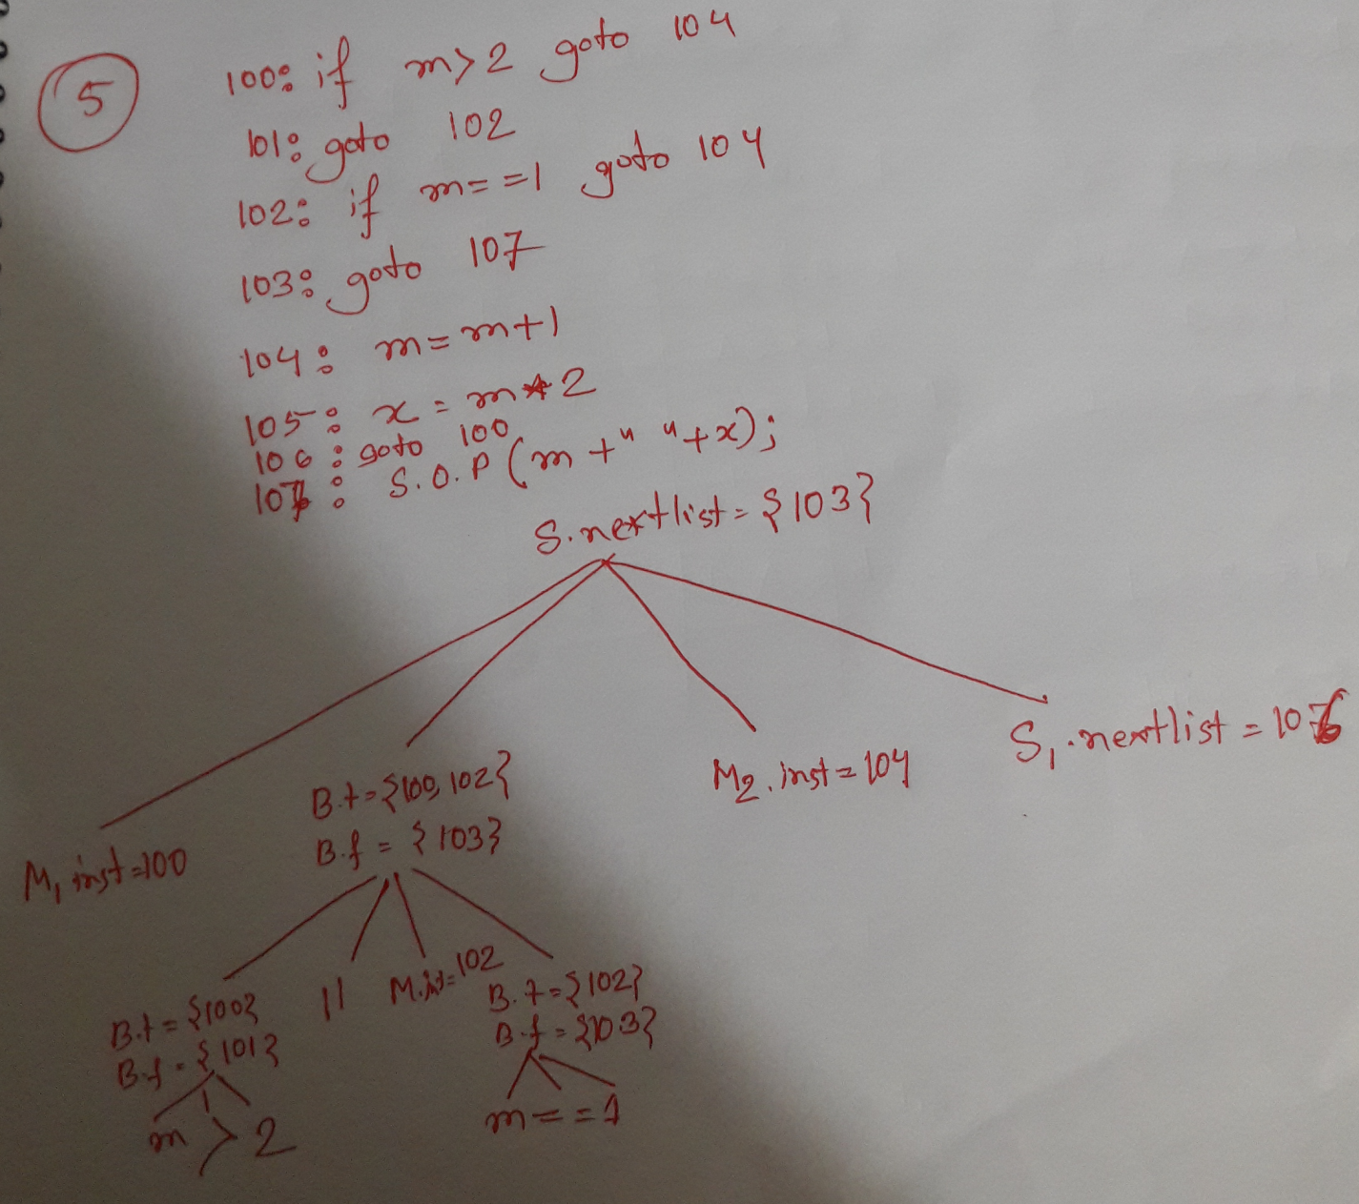

**6.** Draw the block diagrams of following control flow statements: **[3]**

***S -> if( (b>6 || b<10) && a%2==0) x = b+a;***

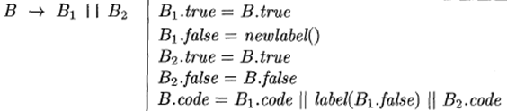

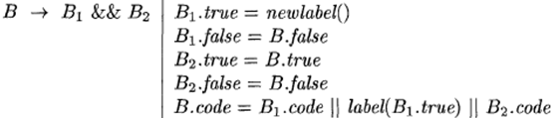

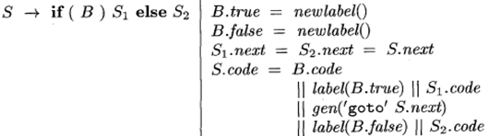

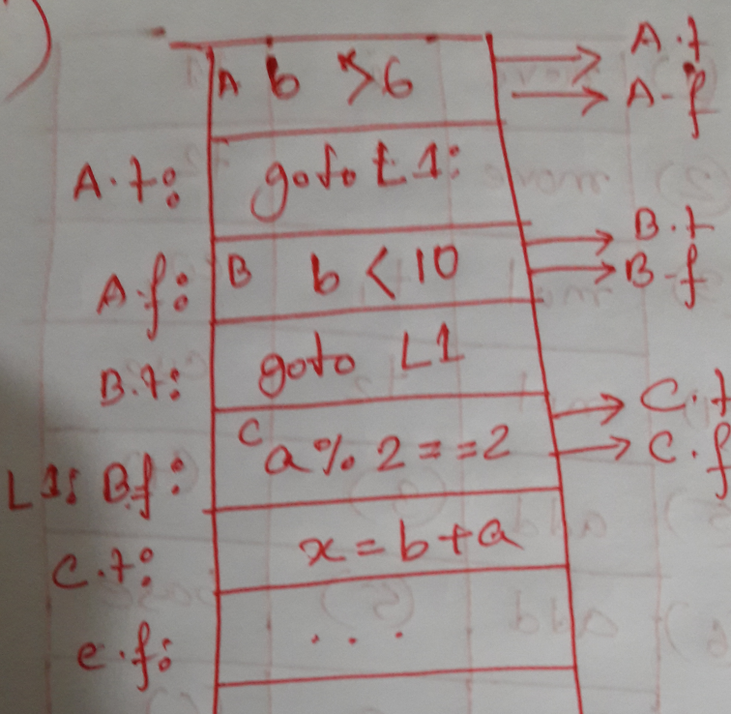

**7.** Construct the LR(1) items and LALR automation of following productions: **[6+2]**

*S-> Bc*

*S-> bAc*

*S-> bBa*

*A->d*

*B->d*

*Almost as same as set A*

**8.** State the major lists of Back-patching. **[1]**

* **Truelist**
* **Falselist**
* **Nextlist**